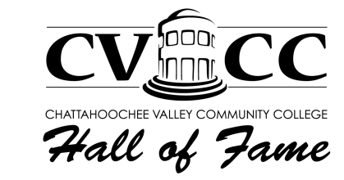

Sponsorship Levels

March 12, 2024 6:00 PM Social, 7:00 PM Program

Platinum - $10,000
- Plaque mounted on CVCC Foundation Wall of Honor
- Logo on four (4) CVCC Hall of Fame Digital Billboards (deadline for Billboards is February 3, 2023)

Tickets for 8 guests- reserved seating

Listing in all Hall of Fame advertisements

Mentions on Social Media

Listing in the event program

Personal acknowledgement during the event

Corporate name and logo on CVCC’s website

Gold - $5,000

Logo on four (4) CVCC Hall of Fame Digital Billboards

Tickets for 8 guests- reserved seating

Listing in all Hall of Fame advertisements

Mentions on Social Media

Listing in the event program

Personal acknowledgement during the event

Corporate name and logo on CVCC’s website

Blue - $2,500

Tickets for 6 guests-open seating

Listing in all Hall of Fame advertisements

Mentions on Social Media

Listing in the event program

Listing on signage at the event

Personal acknowledgement during the event

Corporate Name and logo on CVCC’s website

Pirate - $1,000

Tickets for 4 guests-open seating

Listing in the event program

Personal acknowledgement during the event

Corporate Name and logo on CVCC’s website

Friend - $500

Tickets for 2 guests-open seating

Listing in the event program

Corporate Name on CVCC’s website

Supporter - $250

Ticket for 1 guest-open seating

Corporate Name on CVCC’s website

Listing in the event program
Golden Patron - $100-$249
- Listing in the program

Sponsorship Levels

Hall of Fame Sponsorship Commitment Form

Company/ Sponsor/Patron Name:

Contact Name:

Billing Address:

Phone: Email:

Platinum $10,000 _____

Gold $5,000 _____

Blue $2,500 _____

Pirate $1,000 _____

Friend $500 _____

Supporter $250 _____

Patron $100-$249 _____

Make checks payable to: Chattahoochee Valley Community College Foundation

CVCC Foundation
ATTN: David Fletcher
2602 College Drive
Phenix City, AL 36869
334-291-4938

***NOTE: Please email your company logo to david.fletcher@cv.edu
Sponsorship and Logos must be received by advertising deadline February 9, 2024.
Thank you for your support!

